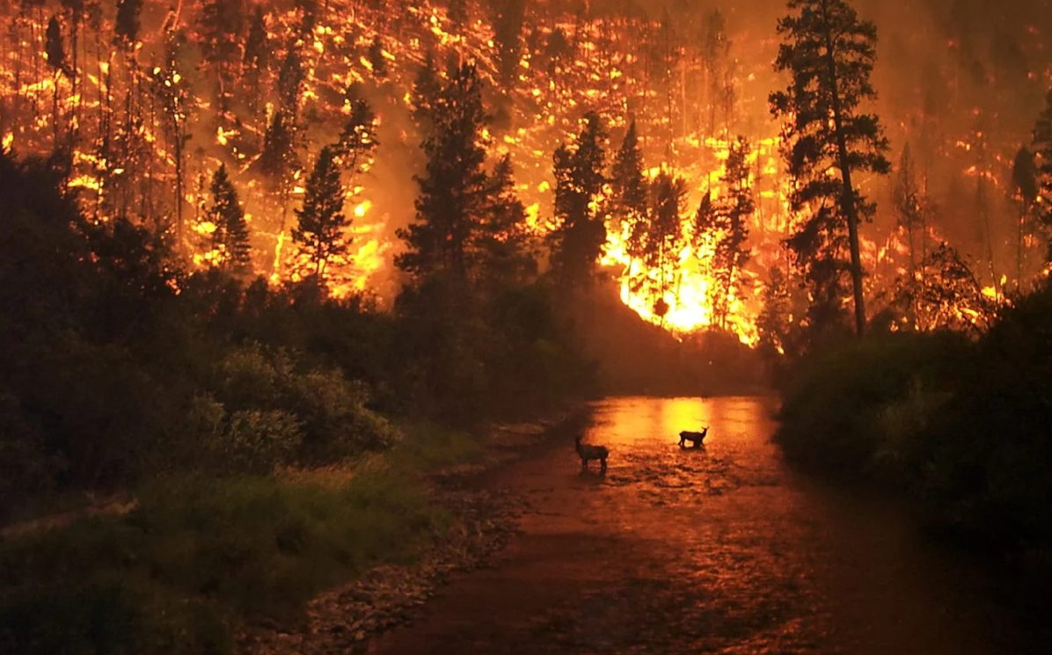

|  |
| --- |
| BLAZING WILDFIRES |
| Analysis of Forest Wildfires in Canada and it’s Mitigation  **Programming For Geodata Processing** |
| January 16  ANUSHA PARIDA  202319026  M.Sc. Agriculture Analytics |



# CONTENTS

# ABSTRACT

# INTRODUCTION

# METHODOLOGY AND DATASETS

# HYPOTHESIS

# DATA VISUALIZATION AND INSIGHTS GAINED FROM THE DATASETS

# LIMITATIONS

# CONCLUSION

# REFERENCES

ABSTRACT

The increase in forest wildfires has been a major concern worldwide and Canada stands out one of country where forest fires has been a burning issue since millennia which needs immediate attention. Here the present condition of the different provinces in Canada has been analyzed with help of figures and datasets from different data sources so that this issue is being reflected for taking proper mitigation measures and reduces future prospects of this issue. From various findings of Canadian Climate Centre GCM scenarios, it has been concluded that if proper measures are not taken the probably there would be increase of these fire accidents by 25% -75% by the end of our era. Through analysis it gives us insight of the various causes contributing to this major issues i.e. mostly due to human activities which interlinks another major problem connected to this is climate changes leading to loss of biodiversity and other environmental problems. From the insights gained the aim is to take sustainable decisions that may result in a resilient ecosystem in Canada.

INTRODUCTION:

Forests which are the major life-giving source to many species, conserves ecosystem and provide many valuable products is burning at an alarming rate. It has been found that forest fires burn up to 2.5 million hectares of land annually in the country. In the last 25 years about approx. 7000 forest fire incidents have occurred. The recent 2023 Canadian wildfire was the most severe and extreme form which broke records from the previous fire incidents in the past years. All the provinces and territories in Canada suffered with critical conditions in Alberta, British Columbia, Northwest Territories, Nova Scotia, Quebec and Ontario provinces. This event has also contributed to higher AQI, increased temperatures leading to drought conditions and climate change.

Globally speaking recent trends show that there has been increase in forest fires by double the amount it did in past 21 years back. Researchers from the University of Maryland, suggest that forest fires have taken up about 2-3 million hectares of land annually as compared to 2000s, an approximate amount of Belgium i.e. a quarter of all vegetation cover in past 20 years. About 6 million hectares of vegetation cover was lost in 2022 with 2023 seeing heightened activities of fire which includes record-breaking fire stats across country like Canada.

According to the reports, it has been found that in 2023 forest fires lead to increased AQI index of 342 in New York which resulted in closing of educational institutions and cancellation of some major events. In British Columbia, there were currently 75 ongoing wildfires and 22 of them were claimed to be out of control. From the beginning of the year, 381 fires burned a large area of about 4,500 sq. kms. Fire in the Fort St. John was the 2nd largest fire accident being recorded affecting about an area of 2,400 sq. kms.

In Alberta currently there were 64 wildfires throughout the province from which 18 were out of control. It has approximately burned about 12,017 sq. kms. of land area. In Quebec, there were about 111 fire incidents being claimed as uncontrollable which burned over 1,731 sq.km of land area. According to news about 10,000 people were evacuated from their houses.

The wildfires also emit about 2100 megatons of carbon annually as estimated. This 2023 was a record-breaking wildfire season as it tripled the country’s annual carbon footprint. These wildfires have been responsible for 30% & 6% of Quebec’s and Canada’s greenhouse gas emissions annually. Black carbon accounted about 5% of air particulates out of total. These events result in 40-90% of black carbon & particulate matter in Canada.

Wildfires not only affect ecosystem but also the mental health of the residents living leading to trauma, anxiety and depression. It was found that about 30% of individuals seeking help at relief centers after the fire accidents generally go through depression and some 20% of people suffer from PTSD. It not only causes destruction of their properties but also is affecting their mental well-being. Likewise, there are several reports of injuries and deaths due to wildfires. Not only direct but it has some indirect impact on well-being of the resident’s unavailability of timber resources, decreases in no. of watershed health.

KEY OBJECTIVES:

* To identify the major causes contributing to wildfires.
* To take essential mitigation steps towards control of this burning issues.
* For preserving ecosystem and biodiversity.
* To take insights from the studies conducted for improvement in certain area.
* To avoid future climate change activities.

METHODOLOGY and DATASETS:

* In first dataset, it contains information about the number of forest fires, area affected, maximum size of land burnt by a single fire, large fires affecting more than 200 hectares of land and small fires data for each year i.e. from 2000-21. The source of this dataset is from Canadian National Fire Database (CNFDB) point data of several places all over Canada affected by forest fires. This data has been used to analyze fire trend over the years.

*[Canadian Wildland Fire Information System | Canadian National Fire Database (CNFDB) (nrcan.gc.ca)](https://cwfis.cfs.nrcan.gc.ca/ha/nfdb)

* In second dataset, it contains information about number of forest fires and area burnt in hectares over 25 years from 2000-23. The sources of this dataset are from Canadian Interagency Forest Fire Centre (CIFFC). These data were used to correlate with the data obtained from first dataset. Proper visualization using charts is done to gain insights from the dataset.

*https://ciffc.net/statistics

* In third dataset, information includes area burnt in hectares in different provinces of Canada in year 2020 from National Forestry Database. This data has been used to know major hotspot areas of forest wildfires so that proper focus can be given to those specific areas at first.

* https://www.statista.com/statistics/553583/area-burned-by-forest-fires-in-canada-by-province-or-territory/

* In fourth dataset, shapefile containing the provinces data is collected to create a hotspot map for better visualization and analysis.

* https://open.canada.ca/data/en/dataset/a883eb14-0c0e-45c4-b8c4-b54c4a819edb/resource/12c03de6-c3f7-4f5f-bb5c-d479f2332842

* In fifth dataset, the various causes responsible for forest fire is being analyzed and visualized so that these activities be controlled to avoid such accidents in future and built a resilient ecosystem. The sources of the dataset are from National Forestry Database for the year 2019 and 2020.

* https://www.statista.com/statistics/553522/number-of-forest-fires-in-canada-by-cause/

HYPOTHESIS:

* Alarming alerts for forest fires globally but Canada witnessed the most devastating and record-breaking fire in 2023. Does it need any mitigation measures?

These articles show the current scenario of forest cover which shows there is need immediate need of action to be taken to prevent further losses. Even though they have good alert system still they weren’t able to control many large fires.

*[Canada's record-breaking wildfire season leaves devastation in its wake | Mint (livemint.com)](https://www.livemint.com/news/world/canadas-record-breaking-wildfire-season-leaves-devastation-in-its-wake-11696212477692.html)

*[Tracking Canada’s Extreme 2023 Fire Season (nasa.gov)](https://earthobservatory.nasa.gov/images/151985/tracking-canadas-extreme-2023-fire-season)

In this research paper the area and number of forest fires trends have been analyzed along with the causes responsible for this for which proper plans and strategies should be taken to avoid it.

*https://www.mdpi.com/2171014.

* Climate change which has been a major critical issue worldwide. Is this responsible for climate change?

*https://www.nature.com/articles/s43247-023-00977-1

In this journal paper the various climatic factors have been analyzed over a certain period of time to know the behavior of this forest fires on climate.

ANALYSIS TO SUPPORT THE HYPOTHESIS:

Datasets are analyzed to show the severity of this issue which is not only reducing the forest cover but also is leading to global climate change. Data from 13 provinces are taken to know which area is more prone to forest fire attack. The major causes are also analyzed to prevent these activities.

DATA VISUALIZATION AND INSIGHTS GAINED FROM THE DATASETS:

1. Comparing the no years in X-axis to that of number of forest fires in y-axis in a bar chart. Time trend analysis has been done to know the increase in number up to 2023. It is clearly evident that the number of forest fires was greater during 2006 which then gradually decreased in the upcoming year then again fluctuations occurred showing an average of approx.6000 fires annually over these 24 years.

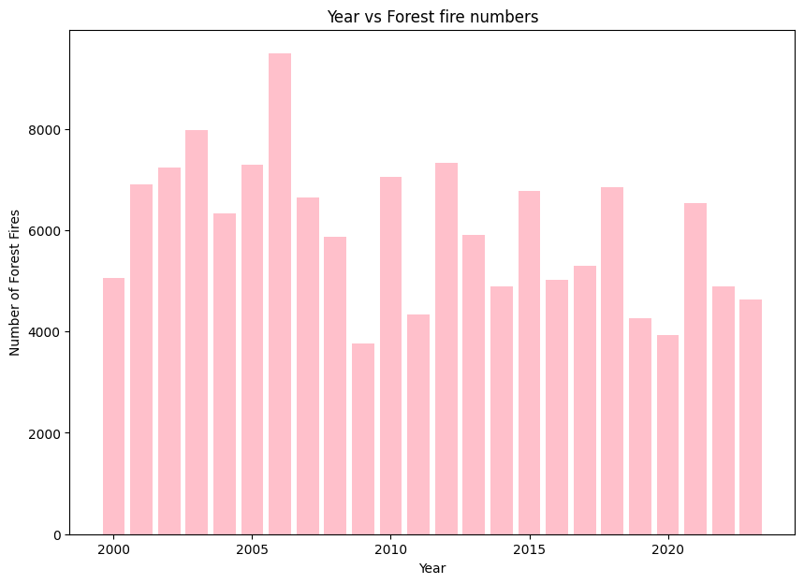

1. Comapring area affected by fire by the no. of years showing an increase in area affected as compared to previous years. The dataset clearly shows that the area affected is 18 times more in 2022 as compared to 2000 resulting in large area of forest cover loss which needs immediate attention if not taken care.

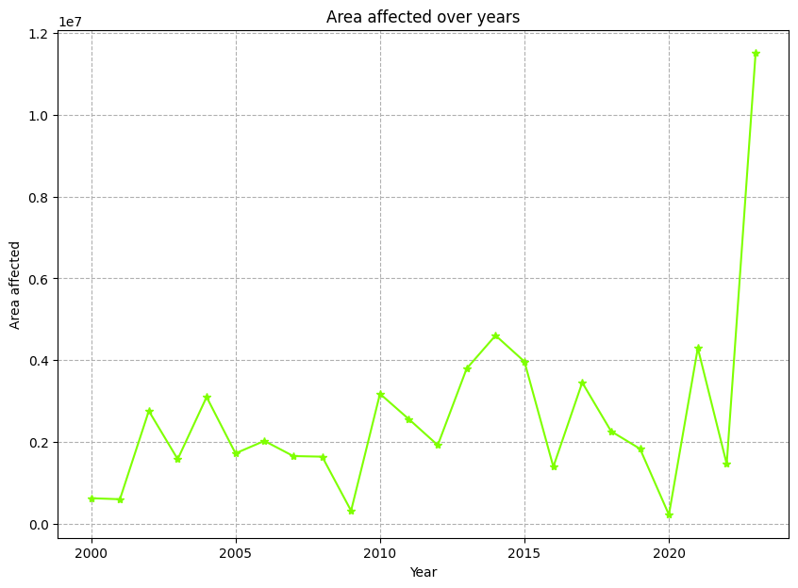

1. From this data we can observe that large fires affecting area greater than 200 hectares were more from 2014-17 which has resulted in heavy loss of large amount of forest area and have faced challenging conditions. From the piechart the fire distribution in 2021 was analyzed showing the percentage of large fires to that of small fire.

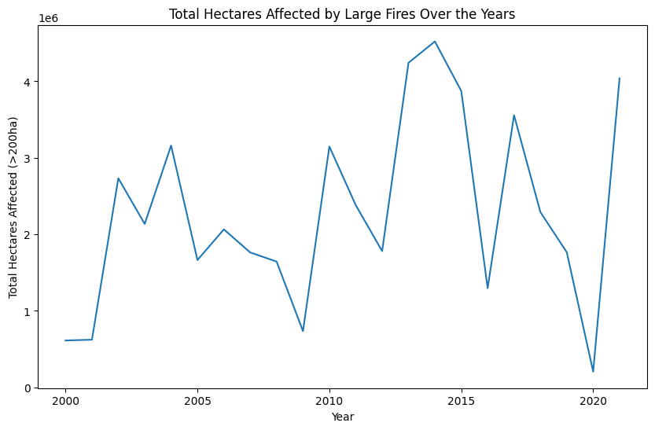

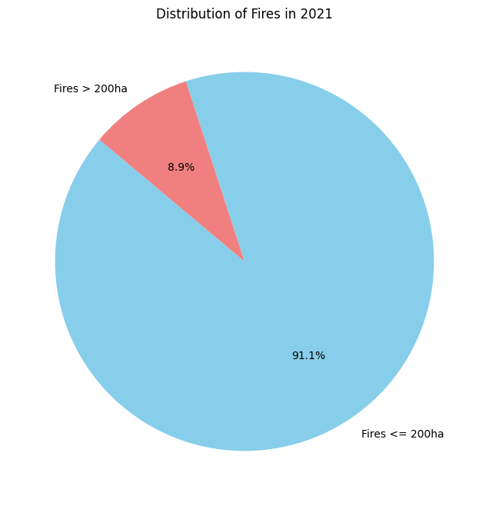

1. Hotspot analysis was done to know which areas were affected in Canada. From this we can see that Alberta, Ontario and British Columbia had highest number forest fires frequency. This shows that these area are more prone to forest fires.

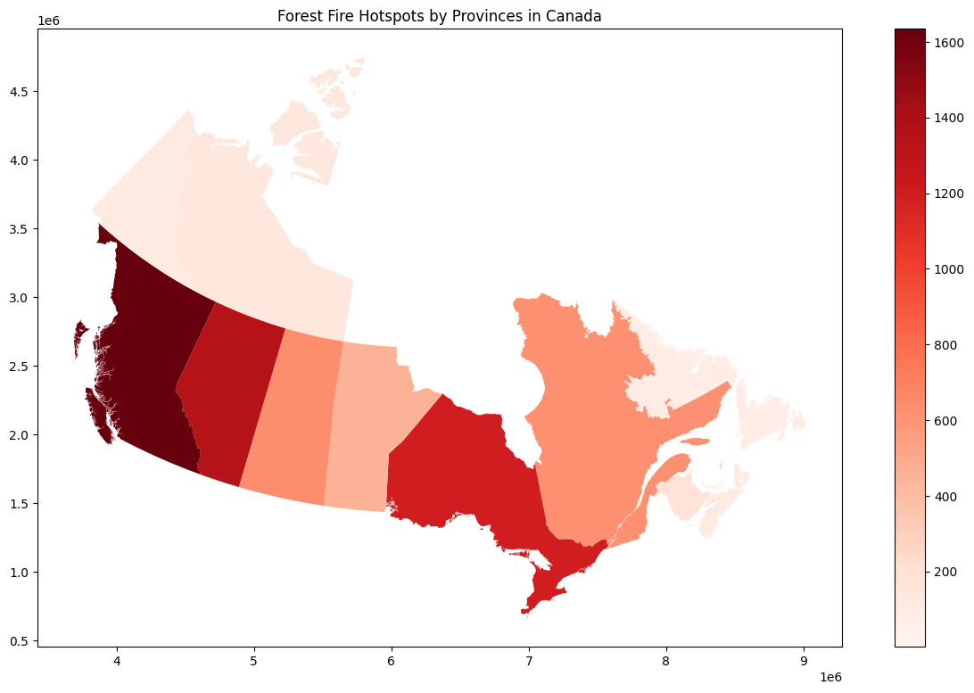

1. The cause of forest fires have been visualized here which shows human activities caused majorly due to accidents and lightning are major cause of forest fires.

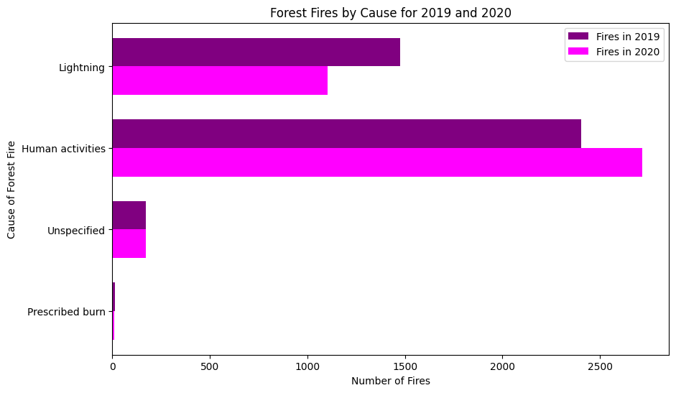

LIMITATIONS:

* The analysis is not based globally as this as a major global concern but my analysis has been restricted to one country.
* Here the climatic factors responsible for this issue are not being analyzed.
* Information about the forest policies and topographic data has not been considered.

CONCLUSION:

From this we can conclude that Canada needs to improve their wildfire management system by developing new innovative ideas and putting more focus for taking mitigation steps and increasing the budget for this issue. They should adopt a technique called prescribed burns as suggested by some experts where forest areas in specific are set on fire in controlled conditions to incinerate trees. As our climate is evolving we need to evolve and find new ways to protect our ecosystem.

REFERENCES:

* <https://www.wri.org/insights/global-trends-forest-fires>
* <https://www.nytimes.com/2023/06/09/world/canada/canada-firefighting-capacity.html>
* [Fifty years of wildland fire science in Canada (cdnsciencepub.com)](https://cdnsciencepub.com/doi/full/10.1139/cjfr-2020-0314)
* <https://spiral.imperial.ac.uk/bitstream/10044/1/105981/17/scientific%20report%20-%20Canada%20wildfires.pdf>
* [CSIRO PUBLISHING | International Journal of Wildland Fire](https://www.publish.csiro.au/WF/WF06091)